USER STORY U1: User Signup

|  |  |
| --- | --- |
| **Purpose:** Verify the user story U1 (all parts).  Instructions: Anything in **RED** is mandatory, everything else is optional and should only be put in if it is needed to clarify how the test was performed. | |
| **Test Run Information:**  **Tester Name:** Pranay Kumar  **Date(s) of Test: -** 05-04-2021 | **Prerequisites for this test:** None |
| **Software Versions:**  Application: Neo Bike Rental Application  Browser [used & those COTS supports]: Google Chrome.  Database: MySQL  Operating System: Windows 10 |
| **Required Configuration:** [ browser setup, security or user ID roles]No special setup needed |
| **NOTES and RESULTS:**  The User Signup is working successfully. | |
| **STEP** | **TEST STEP/ INPUT** | **EXPECTED RESULTSS** | **ACTUAL RESULTS** | **PASS/FAIL** |
| **1.** | Entering email in invalid format | Should get a warning message below the text field that “Invalid Email!!” | Got a warning below the text field that “Invalid Email!!” | **PASS** |
| **2.** | Entering a password that is less than 8 characters | Should get a warning message below the text field that “Invalid Password!!” | Got a warning message below the text field that “Invalid Password!!” | **PASS** |
| **3.** | Entering a mobile number that is less than 10 characters | Should get a warning message below the text field that “Invalid Mobilenumber!! | Got a warning message below the text field that “Invalid Mobilenumber!!” | **PASS** |
| **4.** | Entering all details and clicking on submit button where email or mobile number already exists | Should get an alert saying that “User already exists” | Got an alert saying that “User already exists” | **PASS** |
| **5.** | Entering all valid details and clicking on submit | Should get an alert saying that “Signup successful” | Got an alert saying that “Signup is successful” | **PASS** |
| **6.** | Clicking on “Click Here” beside the Go to Login text | Should go to the Login page and do the login stuff | Redirected to the login page | **PASS** |

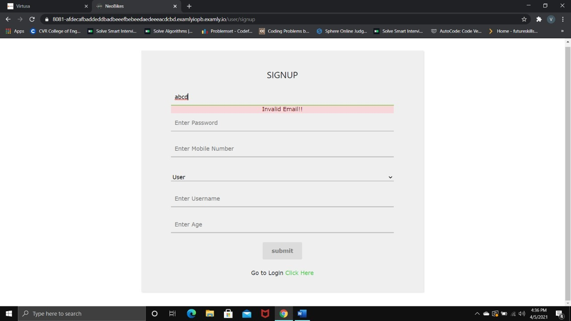

USER STORY U2: User Login

|  |  |
| --- | --- |
| **Purpose:** Verify the user story U2 (all parts).  Instructions: Anything in **RED** is mandatory, everything else is optional and should only be put in if it is needed to clarify how the test was performed. | |
| **Test Run Information:**  **Tester Name:** Pranay Kumar  **Date(s) of Test: -** 05-04-2021 | **Prerequisites for this test:** None |
| **Software Versions:**  Application: Neo Bike Rental Application  Browser [used & those COTS supports]: Google Chrome.  Database: MySQL  Operating System: Windows 10 |
| **Required Configuration:** [ browser setup, security or user ID roles]No special setup needed |
| **NOTES and RESULTS:**  The User Login is working successfully. | |
| **STEP** | **TEST STEP/ INPUT** | **EXPECTED RESULTSS** | **ACTUAL RESULTS** | **PASS/FAIL** |
| **1.** | Entering email in invalid format | Should get a warning message below the text field that “Invalid Email!!” | Got a warning below the text field that “Invalid Email!!” | **PASS** |
| **2.** | Entering a password that is less than 8 characters | Should get a warning message below the text field that “Invalid Password!!” | Got a warning message below the text field that “Invalid Password!!” | **PASS** |
| **3.** | Entering a valid email and password and clicking on submit | Should get an alert saying that “Logged in successfully” | Got an alert saying that “Logged in successfully” | **PASS** |
| **4.** | Clicking on “Ok” button in alert box after login is successful | Should redirect to the user dashboard | Redirected to the user dashboard | **PASS** |
| **5.** | Entering an invalid password | Should get an alert showing “Invalid Credentials” | Got an alert saying that “Invalid Credentials” | **PASS** |
| **6.** | Entering an invalid email | Should get an alert showing “User not Found” and redirect to signup page | Got and alert saying that “User not Found” and redirect to signup page | **PASS** |

|  |  |  |  |
| --- | --- | --- | --- |
|  |  | |  |
|  | |  | |

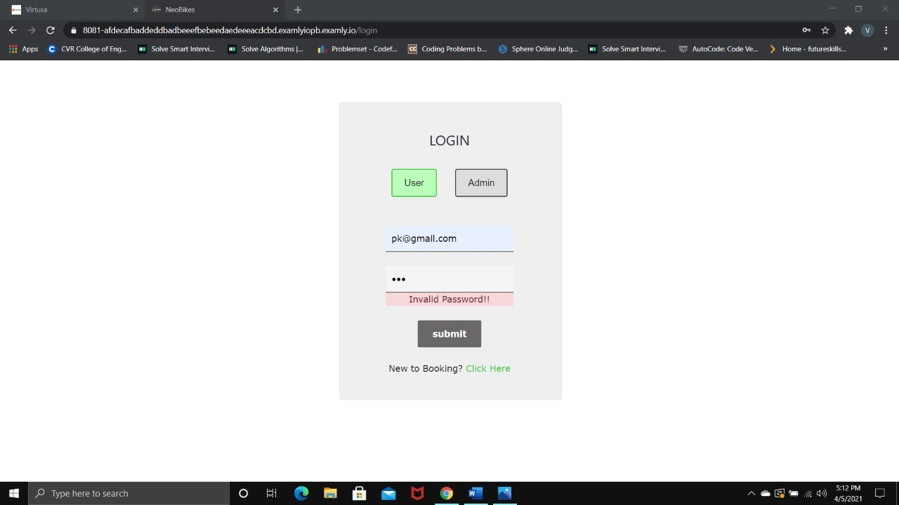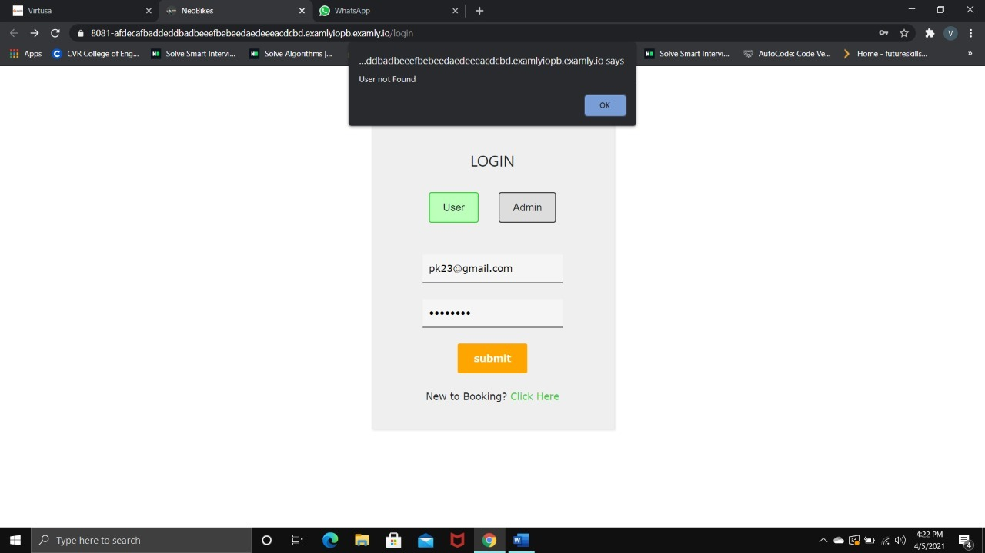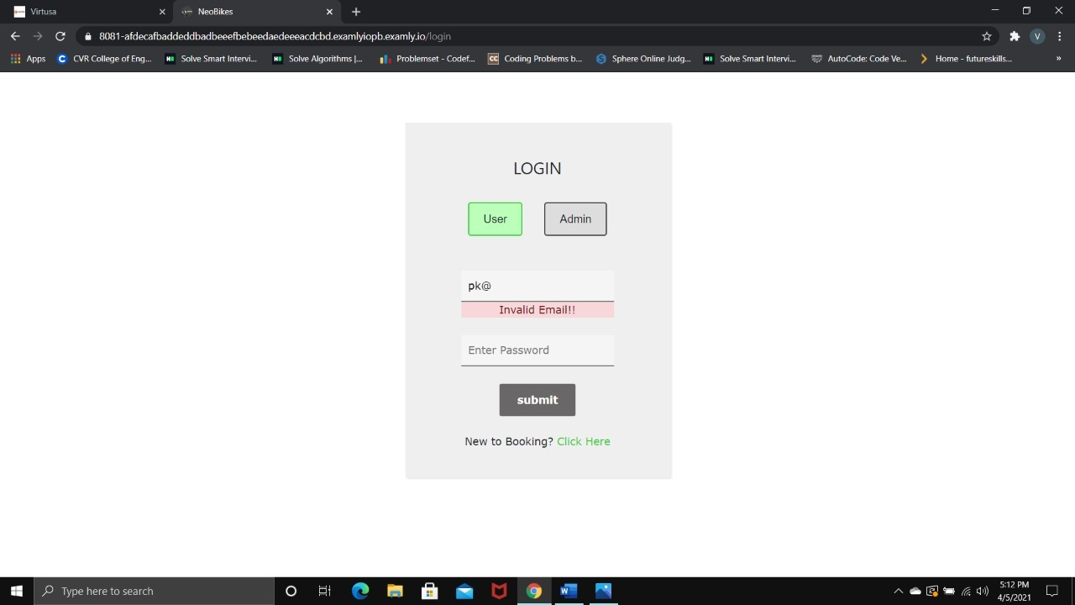

USER STORY U3: User dashboard

|  |  |
| --- | --- |
| **Purpose:** Verify the user story U3 (all parts).  Instructions: Anything in **RED** is mandatory, everything else is optional and should only be put in if it is needed to clarify how the test was performed. | |
| **Test Run Information:**  **Tester Name:** Pranay Kumar  **Date(s) of Test: -** 05-04-2021 | **Prerequisites for this test:** None |
| **Software Versions:**  Application: Neo Bike Rental Application  Browser [used & those COTS supports]: Google Chrome.  Database: MySQL  Operating System: Windows 10 |
| **Required Configuration:** [ browser setup, security or user ID roles]No special setup needed |
| **NOTES and RESULTS:**  The User dashboard is working successfully. | |
| **STEP** | **TEST STEP/ INPUT** | **EXPECTED RESULTSS** | **ACTUAL RESULTS** | **PASS/FAIL** |
| **1.** | On page start up | Should display the available companies that are signed up with the site | Got all company details with the respective locations and the phone numbers with company image | **PASS** |
| **2.** | Clicking on a particular company | Should route to the company details page | Routed to the company details page | **PASS** |

USER STORY U4: User display bikes

|  |  |
| --- | --- |
| **Purpose:** Verify the user story U2 (all parts).  Instructions: Anything in **RED** is mandatory, everything else is optional and should only be put in if it is needed to clarify how the test was performed. | |
| **Test Run Information:**  **Tester Name:** Pranay Kumar  **Date(s) of Test: -** 05-04-2021 | **Prerequisites for this test:** None |
| **Software Versions:**  Application: Neo Bike Rental Application  Browser [used & those COTS supports]: Google Chrome.  Database: MySQL  Operating System: Windows 10 |
| **Required Configuration:** [ browser setup, security or user ID roles]No special setup needed |
| **NOTES and RESULTS:**  The User display bikes is working successfully. | |
| **STEP** | **TEST STEP/ INPUT** | **EXPECTED RESULTSS** | **ACTUAL RESULTS** | **PASS/FAIL** |
| **1.** | On page start up | Should display the details of bikes related to the selected company | Displayed the details of the bikes belonging to that particular company with their availability status, price and type | **PASS** |
| **2.** | Clicking on a particular bike | Should route to the bike details page | Redirected to the bike details page | **PASS** |

USER STORY U5: User Bike Details

|  |  |
| --- | --- |
| **Purpose:** Verify the user story U5 (all parts).  Instructions: Anything in **RED** is mandatory, everything else is optional and should only be put in if it is needed to clarify how the test was performed. | |
| **Test Run Information:**  **Tester Name:** Pranay Kumar  **Date(s) of Test: -** 05-04-2021 | **Prerequisites for this test:** None |
| **Software Versions:**  Application: Neo Bike Rental Application  Browser [used & those COTS supports]: Google Chrome.  Database: MySQL  Operating System: Windows 10 |
| **Required Configuration:** [ browser setup, security or user ID roles]No special setup needed |
| **NOTES and RESULTS:**  The User bike details is working successfully. | |
| **STEP** | **TEST STEP/ INPUT** | **EXPECTED RESULTSS** | **ACTUAL RESULTS** | **PASS/FAIL** |
| **1.** | On Page start up | Should display the details of the bikes | Displayed the details of the bike | **PASS** |
| **2.** | Clicking on the “Book the Bike” button when bike is available | An alert is being shown which says, “Bike Booked successfully” and added to the bookings | Got an alert saying “Bike Booked successfully” and reflected on “My Bookings” | **PASS** |
| **3.** | Trying to click on the button “Book the Bike” when bike is unavailable | Cannot click the button, as the button will be disabled | There is a disabled button | **PASS** |

USER STORY U6: User Navigation Bar

|  |  |
| --- | --- |
| **Purpose:** Verify the user story U2 (all parts).  Instructions: Anything in **RED** is mandatory, everything else is optional and should only be put in if it is needed to clarify how the test was performed. | |
| **Test Run Information:**  **Tester Name:** Pranay Kumar  **Date(s) of Test: -** 05-04-2021 | **Prerequisites for this test:** None |
| **Software Versions:**  Application: Neo Bike Rental Application  Browser [used & those COTS supports]: Google Chrome.  Database: MySQL  Operating System: Windows 10 |
| **Required Configuration:** [ browser setup, security or user ID roles]No special setup needed |
| **NOTES and RESULTS:**  The User navigation bar is working successfully. | |
| **STEP** | **TEST STEP/ INPUT** | **EXPECTED RESULTSS** | **ACTUAL RESULTS** | **PASS/FAIL** |
| **1.** | Clicking on the Dashboard button | Should route to the user dashboard | Routed to the dashboard of the user | **PASS** |
| **2.** | Clicking on the Profile button | Should route to the user profile page | Routed to the profile of the user | **PASS** |
| **3.** | Clicking on the My Booking button | Should route to the user bookings page | Routed to the user bookings and displayed the past bookings of the user | **PASS** |
| **4.** | Clicking on the Logout | Should log out the user and route to the login | Redirected to the login page | **PASS** |

USER STORY U7: User Profile

|  |  |
| --- | --- |
| **Purpose:** Verify the user story U2 (all parts).  Instructions: Anything in **RED** is mandatory, everything else is optional and should only be put in if it is needed to clarify how the test was performed. | |
| **Test Run Information:**  **Tester Name:** Pranay Kumar  **Date(s) of Test: -** 05-04-2021 | **Prerequisites for this test:** None |
| **Software Versions:**  Application: Neo Bike Rental Application  Browser [used & those COTS supports]: Google Chrome.  Database: MySQL  Operating System: Windows 10 |
| **Required Configuration:** [ browser setup, security or user ID roles]No special setup needed |
| **NOTES and RESULTS:**  The User profile is working successfully. | |
| **STEP** | **TEST STEP/ INPUT** | **EXPECTED RESULTSS** | **ACTUAL RESULTS** | **PASS/FAIL** |
| **1.** | On start up | Should display the details of the user | Displayed the details of the user | **PASS** |
| **2.** | Clicking on the “Edit Profile” button | Should route to the edit profile page where user can edit his details | Routed to edit profile tab | **PASS** |

USER STORY U8: User Edit Profile

|  |  |
| --- | --- |
| **Purpose:** Verify the user story U2 (all parts).  Instructions: Anything in **RED** is mandatory, everything else is optional and should only be put in if it is needed to clarify how the test was performed. | |
| **Test Run Information:**  **Tester Name:** Pranay Kumar  **Date(s) of Test: -** 05-04-2021 | **Prerequisites for this test:** None |
| **Software Versions:**  Application: Neo Bike Rental Application  Browser [used & those COTS supports]: Google Chrome.  Database: MySQL  Operating System: Windows 10 |
| **Required Configuration:** [ browser setup, security or user ID roles]No special setup needed |
| **NOTES and RESULTS:**  The User edit profile is working successfully. | |
| **STEP** | **TEST STEP/ INPUT** | **EXPECTED RESULTSS** | **ACTUAL RESULTS** | **PASS/FAIL** |
| **1.** | On start up | Should display the details of the user in editable fields | Displayed the user in editable fields | **PASS** |
| **2.** | Editing user | The data can be edited by changing the data present | Data is edited | **PASS** |
| **3.** | Clicking on the “Save Changes” button | Should alert “Profile edited successfully” and route to profile page again | Got an alert saying that “Logged in successfully” and routed to profile page | **PASS** |

USER STORY U9: User Bookings

|  |  |
| --- | --- |
| **Purpose:** Verify the user story U2 (all parts).  Instructions: Anything in **RED** is mandatory, everything else is optional and should only be put in if it is needed to clarify how the test was performed. | |
| **Test Run Information:**  **Tester Name:** Pranay Kumar  **Date(s) of Test: -** 05-04-2021 | **Prerequisites for this test:** None |
| **Software Versions:**  Application: Neo Bike Rental Application  Browser [used & those COTS supports]: Google Chrome.  Database: MySQL  Operating System: Windows 10 |
| **Required Configuration:** [ browser setup, security or user ID roles]No special setup needed |
| **NOTES and RESULTS:**  The User bookings is working successfully. | |
| **STEP** | **TEST STEP/ INPUT** | **EXPECTED RESULTSS** | **ACTUAL RESULTS** | **PASS/FAIL** |
| **1.** | On start up | Should display the bookings of the user | Displayed all the bookings that the user has done | **PASS** |

USER STORY U10: Admin Signup

|  |  |
| --- | --- |
| **Purpose:** Verify the user story U2 (all parts).  Instructions: Anything in **RED** is mandatory, everything else is optional and should only be put in if it is needed to clarify how the test was performed. | |
| **Test Run Information:**  **Tester Name:** Pranay Kumar  **Date(s) of Test: -** 05-04-2021 | **Prerequisites for this test:** None |
| **Software Versions:**  Application: Neo Bike Rental Application  Browser [used & those COTS supports]: Google Chrome.  Database: MySQL  Operating System: Windows 10 |
| **Required Configuration:** [ browser setup, security or user ID roles]No special setup needed |
| **NOTES and RESULTS:**  The admin signup is working successfully. | |
| **STEP** | **TEST STEP/ INPUT** | **EXPECTED RESULTSS** | **ACTUAL RESULTS** | **PASS/FAIL** |
| **1.** | Entering email in invalid format | Should get a warning message below the text field that “Invalid Email!!” | Got a warning below the text field that “Invalid Email!!” | **PASS** |
| **2.** | Entering a password that is less than 8 characters | Should get a warning message below the text field that “Invalid Password!!” | Got a warning message below the text field that “Invalid Password!!” | **PASS** |
| **3.** | Entering a mobile number that is less than 10 characters | Should get a warning message below the text field that “Invalid Mobilenumber!! | Got a warning message below the text field that “Invalid Mobilenumber!!” | **PASS** |
| **4.** | Entering all details and clicking on submit button where email or mobile number already exists | Should get an alert saying that “Admin already exists” | Got an alert saying that “Admin already exists” | **PASS** |
| **5.** | Entering all valid details and clicking on submit | Should get an alert saying that “Signup successful” | Got an alert saying that “Signup is successful” and routed to admin dashboard | **PASS** |
| **6.** | Clicking on “Click Here” beside the Go to Login text | Should go to the Login page and do the login stuff | Redirected to the login page | **PASS** |

USER STORY U11: Admin Login

|  |  |
| --- | --- |
| **Purpose:** Verify the user story U2 (all parts).  Instructions: Anything in **RED** is mandatory, everything else is optional and should only be put in if it is needed to clarify how the test was performed. | |
| **Test Run Information:**  **Tester Name:** Pranay Kumar  **Date(s) of Test: -** 05-04-2021 | **Prerequisites for this test:** None |
| **Software Versions:**  Application: Neo Bike Rental Application  Browser [used & those COTS supports]: Google Chrome.  Database: MySQL  Operating System: Windows 10 |
| **Required Configuration:** [ browser setup, security or user ID roles]No special setup needed |
| **NOTES and RESULTS:**  The admin Login is working successfully. | |
| **STEP** | **TEST STEP/ INPUT** | **EXPECTED RESULTSS** | **ACTUAL RESULTS** | **PASS/FAIL** |
| **STEP** | **TEST STEP/ INPUT** | **EXPECTED RESULTSS** | **ACTUAL RESULTS** | **PASS/FAIL** |
| **1.** | Entering email in invalid format | Should get a warning message below the text field that “Invalid Email!!” | Got a warning below the text field that “Invalid Email!!” | **PASS** |
| **2.** | Entering a password that is less than 8 characters | Should get a warning message below the text field that “Invalid Password!!” | Got a warning message below the text field that “Invalid Password!!” | **PASS** |
| **3.** | Entering a valid email and password and clicking on submit | Should get an alert saying that “Logged in successfully” | Got an alert saying that “Logged in successfully” | **PASS** |
| **4.** | Clicking on “Ok” button in alert box after login is successful | Should redirect to the admin dashboard | Redirected to the admin dashboard | **PASS** |
| **5.** | Entering an invalid password | Should get an alert showing “Invalid Credentials” | Got an alert saying that “Invalid Credentials” | **PASS** |

USER STORY U12: Admin dashboard

|  |  |
| --- | --- |
| **Purpose:** Verify the user story U3 (all parts).  Instructions: Anything in **RED** is mandatory, everything else is optional and should only be put in if it is needed to clarify how the test was performed. | |
| **Test Run Information:**  **Tester Name:** Pranay Kumar  **Date(s) of Test: -** 05-04-2021 | **Prerequisites for this test:** None |
| **Software Versions:**  Application: Neo Bike Rental Application  Browser [used & those COTS supports]: Google Chrome.  Database: MySQL  Operating System: Windows 10 |
| **Required Configuration:** [ browser setup, security or user ID roles]No special setup needed |
| **NOTES and RESULTS:**  The admin dashboard is working successfully. | |
| **STEP** | **TEST STEP/ INPUT** | **EXPECTED RESULTSS** | **ACTUAL RESULTS** | **PASS/FAIL** |
| **1.** | On page start up | Should display all the bikes that belong to his company along with his earnings | Displayed all the bikes along with their statuses and details, his earnings | **PASS** |
| **2.** | Clicking on the edit button for a bike | Route him to edit bike page | Routed him to edit bike page | **PASS** |
| **3.** | Clicking on the delete button for a bike | Should delete the bike from the admin’s company | Deleted the bike from the company | **PASS** |
| **4.** | Clicking on “Add bike” button | Should route to add bike page | Routed to add bike page | **PASS** |

USER STORY U13: Admin Add Bike

|  |  |
| --- | --- |
| **Purpose:** Verify the user story U3 (all parts).  Instructions: Anything in **RED** is mandatory, everything else is optional and should only be put in if it is needed to clarify how the test was performed. | |
| **Test Run Information:**  **Tester Name:** Pranay Kumar  **Date(s) of Test: -** 05-04-2021 | **Prerequisites for this test:** None |
| **Software Versions:**  Application: Neo Bike Rental Application  Browser [used & those COTS supports]: Google Chrome.  Database: MySQL  Operating System: Windows 10 |
| **Required Configuration:** [ browser setup, security or user ID roles]No special setup needed |
| **NOTES and RESULTS:**  The admin dashboard is working successfully. | |
| **STEP** | **TEST STEP/ INPUT** | **EXPECTED RESULTSS** | **ACTUAL RESULTS** | **PASS/FAIL** |
| **1.** | On page start up | Should open a form where the admin can add the details of the new bike | Displayed a form where user can add details of the bike | **PASS** |
| **2.** | Clicking on “AddBike” button | Should alert “Bike added successfully” and should route to admin dashboard | Alerted “Bike added successfully” and routed to admin dashboard | **PASS** |

USER STORY U14: Admin Edit Bike

|  |  |
| --- | --- |
| **Purpose:** Verify the user story U3 (all parts).  Instructions: Anything in **RED** is mandatory, everything else is optional and should only be put in if it is needed to clarify how the test was performed. | |
| **Test Run Information:**  **Tester Name:** Pranay Kumar  **Date(s) of Test: -** 05-04-2021 | **Prerequisites for this test:** None |
| **Software Versions:**  Application: Neo Bike Rental Application  Browser [used & those COTS supports]: Google Chrome.  Database: MySQL  Operating System: Windows 10 |
| **Required Configuration:** [ browser setup, security or user ID roles]No special setup needed |
| **NOTES and RESULTS:**  The admin edit bike is working successfully. | |
| **STEP** | **TEST STEP/ INPUT** | **EXPECTED RESULTSS** | **ACTUAL RESULTS** | **PASS/FAIL** |
| **1.** | On page start up | Should display a form with values of the bike that is to be edited | Opened a form with the existing values in the place that can be edited | **PASS** |
| **2.** | Click on the “Edit Bike” | Should edit the details of the bike and alert “Bike edited successfully” and route to admin dashboard | Alerted “Bike edited successfully” and routed to admin dashboard | **PASS** |

USER STORY U15: Admin Navigation Bar

|  |  |
| --- | --- |
| **Purpose:** Verify the user story U2 (all parts).  Instructions: Anything in **RED** is mandatory, everything else is optional and should only be put in if it is needed to clarify how the test was performed. | |
| **Test Run Information:**  **Tester Name:** Pranay Kumar  **Date(s) of Test: -** 05-04-2021 | **Prerequisites for this test:** None |
| **Software Versions:**  Application: Neo Bike Rental Application  Browser [used & those COTS supports]: Google Chrome.  Database: MySQL  Operating System: Windows 10 |
| **Required Configuration:** [ browser setup, security or user ID roles]No special setup needed |
| **NOTES and RESULTS:**  The admin navigation bar is working successfully. | |
| **STEP** | **TEST STEP/ INPUT** | **EXPECTED RESULTSS** | **ACTUAL RESULTS** | **PASS/FAIL** |
| **1.** | Clicking on the Dashboard button | Should route to the admin dashboard | Routed to the dashboard of the admin | **PASS** |
| **2.** | Clicking on the Profile button | Should route to the admin profile page | Routed to the profile of the admin | **PASS** |
| **3.** | Clicking on the Bookings button | Should route to the admin bookings page | Routed to the admin bookings and displayed the past bookings of the company | **PASS** |
| **4.** | Clicking on the Logout | Should log out the admin and route to the login | Redirected to the login page | **PASS** |

USER STORY U16: Admin Profile

|  |  |
| --- | --- |
| **Purpose:** Verify the user story U2 (all parts).  Instructions: Anything in **RED** is mandatory, everything else is optional and should only be put in if it is needed to clarify how the test was performed. | |
| **Test Run Information:**  **Tester Name:** Pranay Kumar  **Date(s) of Test: -** 05-04-2021 | **Prerequisites for this test:** None |
| **Software Versions:**  Application: Neo Bike Rental Application  Browser [used & those COTS supports]: Google Chrome.  Database: MySQL  Operating System: Windows 10 |
| **Required Configuration:** [ browser setup, security or user ID roles]No special setup needed |
| **NOTES and RESULTS:**  The admin profile is working successfully. | |
| **STEP** | **TEST STEP/ INPUT** | **EXPECTED RESULTSS** | **ACTUAL RESULTS** | **PASS/FAIL** |
| **1.** | On start up | Should display the details of the admin | Displayed the details of the admin | **PASS** |
| **2.** | Clicking on the “Edit Profile” button | Should route to the edit profile page where admin can edit his details | Routed to edit profile tab | **PASS** |

USER STORY U17: Admin Edit Profile

|  |  |
| --- | --- |
| **Purpose:** Verify the user story U2 (all parts).  Instructions: Anything in **RED** is mandatory, everything else is optional and should only be put in if it is needed to clarify how the test was performed. | |
| **Test Run Information:**  **Tester Name:** Pranay Kumar  **Date(s) of Test: -** 05-04-2021 | **Prerequisites for this test:** None |
| **Software Versions:**  Application: Neo Bike Rental Application  Browser [used & those COTS supports]: Google Chrome.  Database: MySQL  Operating System: Windows 10 |
| **Required Configuration:** [ browser setup, security or user ID roles]No special setup needed |
| **NOTES and RESULTS:**  The admin edit profile is working successfully. | |
| **STEP** | **TEST STEP/ INPUT** | **EXPECTED RESULTSS** | **ACTUAL RESULTS** | **PASS/FAIL** |
| **1.** | On start up | Should display the details of the admin in editable fields | Displayed the admin in editable fields | **PASS** |
| **2.** | Editing admin | The data can be edited by changing the data present | Data is edited | **PASS** |
| **3.** | Clicking on the “Save Changes” button | Should alert “Profile edited successfully” and route to profile page again | Got an alert saying that “Logged in successfully” and routed to profile page | **PASS** |

USER STORY U18: Admin Bookings

|  |  |
| --- | --- |
| **Purpose:** Verify the user story U2 (all parts).  Instructions: Anything in **RED** is mandatory, everything else is optional and should only be put in if it is needed to clarify how the test was performed. | |
| **Test Run Information:**  **Tester Name:** Pranay Kumar  **Date(s) of Test: -** 05-04-2021 | **Prerequisites for this test:** None |
| **Software Versions:**  Application: Neo Bike Rental Application  Browser [used & those COTS supports]: Google Chrome.  Database: MySQL  Operating System: Windows 10 |
| **Required Configuration:** [ browser setup, security or user ID roles]No special setup needed |
| **NOTES and RESULTS:**  The admin bookings is working successfully. | |
| **STEP** | **TEST STEP/ INPUT** | **EXPECTED RESULTSS** | **ACTUAL RESULTS** | **PASS/FAIL** |
| **1.** | On start up | Should display the bookings of that company where admin belongs to | Displayed the previous bookings of the company | **PASS** |

USER STORY U19: Super Admin Login

|  |  |
| --- | --- |
| **Purpose:** Verify the user story U2 (all parts).  Instructions: Anything in **RED** is mandatory, everything else is optional and should only be put in if it is needed to clarify how the test was performed. | |
| **Test Run Information:**  **Tester Name:** Pranay Kumar  **Date(s) of Test: -** 05-04-2021 | **Prerequisites for this test:** None |
| **Software Versions:**  Application: Neo Bike Rental Application  Browser [used & those COTS supports]: Google Chrome.  Database: MySQL  Operating System: Windows 10 |
| **Required Configuration:** [ browser setup, security or user ID roles]No special setup needed |
| **NOTES and RESULTS:**  The super admin login is working successfully. | |
| **STEP** | **TEST STEP/ INPUT** | **EXPECTED RESULTSS** | **ACTUAL RESULTS** | **PASS/FAIL** |
| **1.** | Entering an invalid email or password | Should get an alert saying that “Email and Password didn’t match” | Got an alert saying, “Email and Password didn’t match” | **PASS** |
| **2.** | Entering a valid email and password | Should get an alert saying that “Logged in Successfully” and route to super admin dashboard | Got an alert saying, “Logged in successfully” and routed to super admin dashboard | **PASS** |

USER STORY U20: Super Admin Dashboard

|  |  |
| --- | --- |
| **Purpose:** Verify the user story U2 (all parts).  Instructions: Anything in **RED** is mandatory, everything else is optional and should only be put in if it is needed to clarify how the test was performed. | |
| **Test Run Information:**  **Tester Name:** Pranay Kumar  **Date(s) of Test: -** 05-04-2021 | **Prerequisites for this test:** None |
| **Software Versions:**  Application: Neo Bike Rental Application  Browser [used & those COTS supports]: Google Chrome.  Database: MySQL  Operating System: Windows 10 |
| **Required Configuration:** [ browser setup, security or user ID roles]No special setup needed |
| **NOTES and RESULTS:**  The super admin dashboard is working successfully. | |
| **STEP** | **TEST STEP/ INPUT** | **EXPECTED RESULTSS** | **ACTUAL RESULTS** | **PASS/FAIL** |
| **1.** | On start up | Should display the details of the admin | Displayed the details of the admin | **PASS** |
| **2.** | Clicking on delete button | Should get an alert saying that “Admin deleted successfully” | Got an alert saying that “Admin deleted successfully” | **PASS** |

USER STORY U21: Super Admin Navigation Bar

|  |  |
| --- | --- |
| **Purpose:** Verify the user story U2 (all parts).  Instructions: Anything in **RED** is mandatory, everything else is optional and should only be put in if it is needed to clarify how the test was performed. | |
| **Test Run Information:**  **Tester Name:** Pranay Kumar  **Date(s) of Test: -** 05-04-2021 | **Prerequisites for this test:** None |
| **Software Versions:**  Application: Neo Bike Rental Application  Browser [used & those COTS supports]: Google Chrome.  Database: MySQL  Operating System: Windows 10 |
| **Required Configuration:** [ browser setup, security or user ID roles]No special setup needed |
| **NOTES and RESULTS:**  The super admin navigation bar is working successfully. | |
| **STEP** | **TEST STEP/ INPUT** | **EXPECTED RESULTSS** | **ACTUAL RESULTS** | **PASS/FAIL** |
| **1.** | Clicking on dashboard | Should route to super admin dashboard page | Routed to super admin dashboard | **PASS** |
| **2.** | Clicking on All Bookings | Should route to all bookings page | Routed to all bookings page | **PASS** |
| **3.** | Clicking on Log out | Should log out of the account and redirect to the super admin login page | Logged out of the account and redirected to the super admin login page | **PASS** |

USER STORY U22: Super Admin Bookings

|  |  |
| --- | --- |
| **Purpose:** Verify the user story U2 (all parts).  Instructions: Anything in **RED** is mandatory, everything else is optional and should only be put in if it is needed to clarify how the test was performed. | |
| **Test Run Information:**  **Tester Name:** Pranay Kumar  **Date(s) of Test: -** 05-04-2021 | **Prerequisites for this test:** None |
| **Software Versions:**  Application: Neo Bike Rental Application  Browser [used & those COTS supports]: Google Chrome.  Database: MySQL  Operating System: Windows 10 |
| **Required Configuration:** [ browser setup, security or user ID roles]No special setup needed |
| **NOTES and RESULTS:**  The super admin bookings is working successfully. | |
| **STEP** | **TEST STEP/ INPUT** | **EXPECTED RESULTSS** | **ACTUAL RESULTS** | **PASS/FAIL** |
| **1.** | On start up | Should display all the booking details of all the users and admins | Displayed all the bookings details | **PASS** |

USER STORY U23: Error Page

|  |  |
| --- | --- |
| **Purpose:** Verify the user story U2 (all parts).  Instructions: Anything in **RED** is mandatory, everything else is optional and should only be put in if it is needed to clarify how the test was performed. | |
| **Test Run Information:**  **Tester Name:** Pranay Kumar  **Date(s) of Test: -** 05-04-2021 | **Prerequisites for this test:** None |
| **Software Versions:**  Application: Neo Bike Rental Application  Browser [used & those COTS supports]: Google Chrome.  Database: MySQL  Operating System: Windows 10 |
| **Required Configuration:** [ browser setup, security or user ID roles]No special setup needed |
| **NOTES and RESULTS:**  The error page is working successfully. | |
| **STEP** | **TEST STEP/ INPUT** | **EXPECTED RESULTSS** | **ACTUAL RESULTS** | **PASS/FAIL** |
| **1.** | If an invalid URL is entered | Should route to error page | Routed to error page | **PASS** |

USER STORY U24: Auth Guard

|  |  |
| --- | --- |
| **Purpose:** Verify the user story U2 (all parts).  Instructions: Anything in **RED** is mandatory, everything else is optional and should only be put in if it is needed to clarify how the test was performed. | |
| **Test Run Information:**  **Tester Name:** Pranay Kumar  **Date(s) of Test: -** 05-04-2021 | **Prerequisites for this test:** None |
| **Software Versions:**  Application: Neo Bike Rental Application  Browser [used & those COTS supports]: Google Chrome.  Database: MySQL  Operating System: Windows 10 |
| **Required Configuration:** [ browser setup, security or user ID roles]No special setup needed |
| **NOTES and RESULTS:**  The auth guard is working successfully. | |
| **STEP** | **TEST STEP/ INPUT** | **EXPECTED RESULTSS** | **ACTUAL RESULTS** | **PASS/FAIL** |
| **1.** | If an unauthorized person tries to access any page other than login, signup | He will be routed to the corresponding login page | Routed to the corresponding login page | **PASS** |